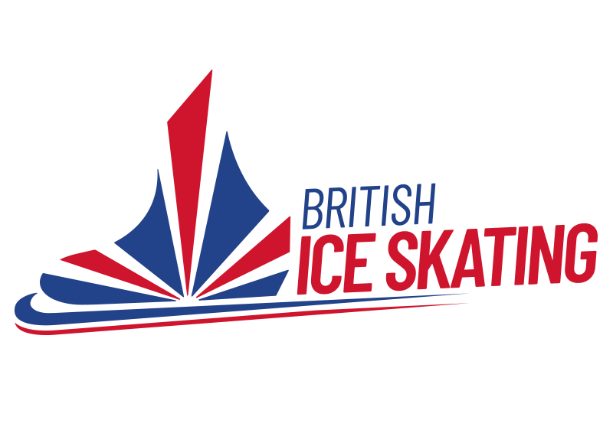

Event Restructure for Singles
Effective from 1st July 2024
This document contains the events in relation to Women/Girls and Men/Boys for Singles Skating.
There are 5 main categories of events: Qualifier/British, BIS Cup Series/Final, Pre-Novice, Open & Adults.
Competition Criteria’s will be finalised after ISU Congress (mid June 2024) as programme criteria is expected to change pending votes by ISU member federations. We expect no changes to Beginner to National 3 at this time.
Please note: we understand some skaters are competing with ‘old’ tests. If you fall into this category we will be updating your qualifications before 1st of July 2024. You may receive some additional certificates. This is hoped to stop any issues you may have when entering competitions. Please complete this form after 1st of July if this is not showing on your profile so it can be updated.
*Ages are provisional based on ISU Communication No. 2624 and therefore may be subject to changing pending decisions which will be confirmed during congress (mid June 2024).
Last updated: 24/04/2024

Qualifiers & British Championships
British Ice Skating is responsible for hosting the Qualifier and British Championship of which the categories are outlined below. Qualifiers and Championships are held in line with ISU Programme Criteria. Skaters must meet the age criteria, the minimum standard and the minimum score to enter to compete in a qualifier. The minimum scores for the 24/25 season will be confirmed after the ISU Congress – this is due to changes in programme requirements which depend on voting from federations across the globe. Skaters who already hold the score from the 23/24 season will be able to enter but must apply for the score. Rankings from the championships will be created from the August 2024 and October 2024 Qualifiers.
Name of Category | Competition Criteria to be followed  (ISU Rules) | Age at 1st of July 2024 | Minimum Skills  Test | Minimum National  Technical | Minimum National  Components | Minimum Score  (if achieved in the 23/24 Season) | Minimum Score  (if achieved 24/25 Season) | Top Qualifier Rankings for British Championships
Basic Novice Girls | Basic Novice | Not reached 14* | 4 | 4 | 4 | 12.3 |  | 30
Basic Novice Boys | Basic Novice | Not reached 14* | 4 | 4 | 4 | 12.3 |  | 10
Advanced Novice Girls | Advanced Novice Girls SP | Not reached 16* | 6 | 6 | 6 | 12.0 |  | 24
 | Advanced Novice Girls FP |  |  |  |  | 19.5
Advanced Novice Boys | Advanced Novice Boys SP | Not reached 16* | 6 | 6 | 6 | 12.0 |  | 10
 | Advanced Novice Boys FP |  |  |  |  | 19.5
Junior Women | Junior Women SP | Not reached 19* | 7 | 7 | 7 | 15.5 |  | 18
 | Junior Women FP |  |  |  |  | 25.5
Junior Men | Junior Men SP | Not reached 19* | 7 | 7 | 7 | 16.5 |  | 10
 | Junior Men FP |  |  |  |  | 25.5
Senior Women | Senior Women SP | No age restrictions | 8 | 8 | 8 | 17.0 |  | 8
 | Senior Women FP |  |  |  |  | 32.0
Senior Men | Senior Men SP | No age restrictions | 8 | 8 | 8 | 22.0 |  | 8
 | Senior Men FP |  |  |  |  | 38.0

Pre-Novice
Pre-Novice Competitions will be held alongside Qualifier Events and will be held by British Ice Skating. Those competing in National 1, National 2 or National 3 will be eligible to join the Pre-Novice Team. Please note: Requirements to join the Team will be reviewed early 2025 ahead of the 25/26 Season.
Name of Event | Competition Criteria  to be followed | Age at 1st of July 2024 | Minimum Skills  Test | Minimum National  Technical  Test | Minimum National  Program Component  Test
Pre-Novice - Under 8 Girls | Beginner | Not reached 9* | Completed Passport
Pre-Novice - Under 8 Boys | Beginner | Not reached 9* | Completed Passport
Pre-Novice – Under 9 Girls | National 1 | Not reached 10* | 1 | 1 | 1
Pre-Novice – Under 9 Boys | National 1 | Not reached 10* | 1 | 1 | 1
Pre-Novice – Under 10 Girls | National 2 | Not reached 11* | 2 | 2 | 2
Pre-Novice – Under 10 Boys | National 2 | Not reached 11* | 2 | 2 | 2
Pre-Novice – Under 11 Girls | National 3 | Not reached 12* | 3 | 3 | 3
Pre-Novice – Under 11 Boys | National 3 | Not reached 12* | 3 | 3 | 3

BIS Cup Series & BIS Cup Final
British Ice Skating is responsible for hosting the Series and British Ice Skating Cup of which the categories are outlined below. Series and Finals are held in line with BIS Generic Criteria. Skaters must meet the age criteria and the minimum standard to compete in the series. Where skaters are eligible for more than one event, they should skate in the highest level. If the skater advances to the next level within the season 2024/2025 they can move up. The rankings will be created from the series events only, providing a final for those ranked in the top places. If skaters are eligible for the final in more than one event, they will have to skate the highest only. Once a skater has competed in a British Championship Qualifier event in the 24/25 season a skater cannot return to BIS Cup Series Event or Final.
Name of Event | Competition Criteria  to be followed | Age at 1st of July 2024 | Minimum Skills  Test | Minimum National  Technical  Test | Minimum National  Program Component  Test | Top BIS Cup Series Rankings for BIS Cup
BIS Cup – National 4 – Girls | National 4 | Must have reached 14* | 4 | 4 | 4 | 30
BIS Cup – National 4 – Boys | National 4 | Must have reached 14* | 4 | 4 | 4 | 10
BIS Cup – National 5 – Girls | National 5 | Must have reached 14* | 5 | 5 | 5 | 30
BIS Cup – National 5 – Boys | National 5 | Must have reached 14* | 5 | 5 | 5 | 10
BIS Cup – National 6 – Girls | National 6 Free | Must have reached 16* | 6 | 6 | 6 | 24
BIS Cup – National 6 – Boys | National 6 Free | Must have reached 16* | 6 | 6 | 6 | 10
BIS Cup – National 7 – Women | National 7 Free | Must have reached 17* | 7 | 7 | 7 | 18
BIS Cup – National 7 – Men | National 7 Free | Must have reached 17* | 7 | 7 | 7 | 14
BIS Cup – National 8– Women | National 8 Free | Must have reached 17* | 7 | 7 | 7 | 8
BIS Cup – National 8 – Men | National 8 Free | Must have reached 17* | 7 | 7 | 7 | 6

Open Events
These are events which are mainly held by affiliated clubs and rinks. These events must be split by gender, and can be split by age at the organisers discretion but there must be no minimum or maximum age for participation.
 | Competition Criteria  to be followed | Minimum Skills  Test | Minimum National  Technical  Test | Minimum National  Program Component  Test
Beginner Girls | Beginner | Completed Passport
Beginner Boys | Beginner | Completed Passport
National 1 Girls | National 1 | 1 | N/A | N/A
National 1 Boys | National 1 | 1 | N/A | N/A
National 2 Girls | National 2 | 2 | 1 | 1
National 2 Boys | National 2 | 2 | 1 | 1
National 3 Girls | National 3 | 3 | 2 | 2
National 3 Boys | National 3 | 3 | 2 | 2
National 4 Girls | National 4 | 4 | 3 | 3
National 4 Boys | National 4 | 4 | 3 | 3
National 5 Girls | National 5 | 5 | 4 | 4
National 5 – Boys | National 5 | 5 | 4 | 4
National 6 Girls – Short Programme | National 6 – Short Programme | 6 | 5 | 5
National 6 Boys – Short Programme | National 6 – Short Programme | 6 | 5 | 5
National 6 Girls – Free Programme | National 6 – Free Programme | 6 | 5 | 5
National 6 Boys – Free Programme | National 6 – Free Programme | 6 | 5 | 5
National 7 Women – Short Programme | National 7 – Short Programme | 7 | 6 | 6
National 7 Men – Short Programme | National 7 – Short Programme | 7 | 6 | 6
National 7 Women – Free Programme | National 7 – Free Programme | 7 | 6 | 6
National 7 Men – Free Programme | National 7 – Free Programme | 7 | 6 | 6
National 8 Women – Short Programme | National 8 – Short Programme | 8 | 7 | 7
National 8 Men – Short Programme | National 8 – Short Programme | 8 | 7 | 7
National 8 Women – Free Programme | National 8 – Free Programme | 8 | 7 | 7
National 8 Men – Free Programme | National 8 – Free Programme | 8 | 7 | 7

Adults & Adult Nationals
British Ice Skating is responsible for hosting Adult Nationals but clubs are welcome to hold Adult Competitions as part of their Open Events. These events must be split by gender, and can provide further split by age at the organisers’ discretion. There are no maximum test requirements, however, athletes should skate at an appropriate level for fair competition depending on their own personal circumstances. British Ice Skating and the Singles & Pairs intend to introduce minimum technical and component standards in the 25/26 season once achievable competitive test claims from adult competitions have been finalised (expected no later than 1st of July 2024).
Name of Event | Competition Criteria  to be followed | Age at 1st of July 2024 | Minimum Skills  Test | Minimum National  Technical  Test | Minimum National  Program Component  Test
Pre-Bronze Young Adults | Beginner Generic Criteria | Minimum 18  Not reached 28 | Completed Passport
Pre-Bronze Adults | Beginner Generic Criteria | Must have reached 28 | Completed Passport
Bronze Young Adults | ISU Bronze Criteria | Minimum 18  Not reached 28 | 1
Bronze ISU Adults | ISU Bronze Criteria | Must have reached 28 | 1
Silver Young Adults | ISU Silver Criteria | Minimum 18  Not reached 28 | 2
Silver ISU Adults | ISU Silver Criteria | Must have reached 28 | 2
Gold Young Adults | ISU Gold Criteria | Minimum 18  Not reached 28 | 3
Gold ISU Adults | ISU Gold Criteria | Must have reached 28 | 3
Master Young Adults | ISU Master Criteria | Minimum 18  Not reached 28 | 4
Master ISU Adults | ISU Master Criteria | Must have reached 28 | 4

