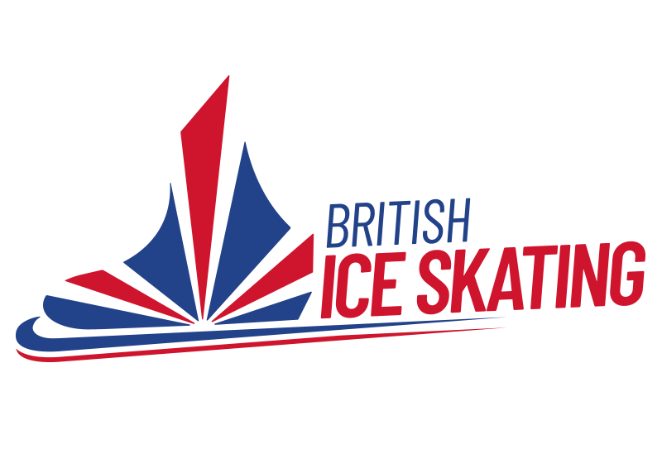

Assistant Coach

Ice Skating

Successful completion of this qualification will allow the candidate to be awarded the qualification of “British Ice Skating Assistant Coach” which allows them to teach the Learn to Skate, Skate UK Programme independently and insured in group sessions with renumeration being permitted.

Last updated: 07/05/2024

Pre-requisite
- Registration and fee
- Full current BIS membership
- Minimum age: 16yrs on application
- Minimum skating level: hold BIS skills 1 or be capable of passing the BIS Coach Competency Test.
- Complete eligibility form (only required if you still wish to compete/participate in shows)

Module 1 – Maximising Participant Experience
- “The Collective” Workshop
This workshop aims to allow the trainee to gain a better understanding of their role as a coach, and how this aligns to the objectives of a learn to skate programme, as well as cater for the needs of the individual participant. Covering areas such as communication, feedback, teamwork, and duty of care aims to give the trainee coach a holistic view to their role within the sport.

Module 2 – Welfare of Participants
- Equality, Diversity & Inclusion Interactive Workshop
Equality, diversity and inclusion, (EDI), is just that; diverse. Each year the BIS EDI lead covers areas and topics which have relevance in today's world, to equip the coaches with insightful information, tips, and guidance so they can accommodate all demographics of society in a respectful and inclusive manor.
- UK Coaching Safeguarding Classroom Session
This session will cover safeguarding issues such as understanding vulnerability, understanding professional boundaries, forms of abuse and how to identify it, and how to report suspected abuse.

Module 3 – The Coaching Assistant Role
- UK Coaching Get into Coaching: Assistant Coach in Sport & Physical Activity eLearning course Workshop
This UK Coaching course will allow trainees to explore the roles and responsibilities of an assistant coach via interactive activities. This will help trainees gain an understanding of safe and ethical practice as well as how to conduct a session, including warming up and cooling down.

Module 4 – Professional Practice
- Professional Practice Workshop
This online session will go through generic professional practices to help the trainee consider their actions and behaviour in a coaching context. This session will cover a variety of topics to ensure the trainee understands the vast responsibilities and how best to tackle them to help them run an efficient business.
- Practical First Aid Course (Not included – must be arranged by candidate)

The ability to provide first aid to a student is a necessity as a coach. There will be times when a student just needs a 2min rest after a hard fall, or a plaster after a small cut, however, there may also be times when more serious injuries happen, such as a head injury, and a coach must know how to deal with that. A respectable first aid course will give the trainee the skills needed to act accordingly in any scenario they find themselves in.
- DBS/PVG (Not included – must be arranged by candidate)
This allows BIS, and other employers, access to essential information to safeguard participants.

Module 5 – Plan, Coach, Reflect
- UK coaching How to: Plan, Coach and Reflect
This Plan, Coach and Reflect course by UK Coaching will allow trainees to understand the continuous process of coaching and become effective coaches by meeting the needs and expectations of the participants.

Module 6 – Skate UK Coaches Guide Workshop
- Skate UK Workshop, including how to teach the dispensation model
This module will enable trainees to understand the syllabus of the Skate UK, as well as gain understanding of the content. The mentor lead, interactive, on ice session, will enable trainees to explore coaching styles via peer-to-peer learning and professional discussion. By the end of the session trainees will have gained knowledge in the foundations of ice skating as well as additional coaching methods they can use to relay information to their participants.

Module 7 – Mentored Hours.
- A minimum of 30 mentored hours with your chosen mentor.
  - This should include a minimum of 16hrs of Skate UK* observation sessions. You must observe at least 2 sessions per level of the Skate UK* curriculum and these sessions require recorded notes via the mentor cards provided, which must then be uploaded to your Sport80 profile.
  - This should also include a minimum of 8hrs of Skate UK* delivery sessions, monitored by your mentor. You must deliver at least 1 session per level of the Skate UK* curriculum and these sessions require a lesson plan (including reflective findings) via the mentor cards provided, which must then be uploaded to your Sport80 profile. Please note, delivery of Skate UK classes may only occur once modules 1 – 5 have been completed.
  - ALL mentored hours should be done under the supervision of your BIS-approved mentor. Your chosen mentor must have completed the BIS Mentoring Training Programme, and either:
- Hold a valid Level 2 BIS Coaching License and have been qualified at Level 2 for three years or more
OR
- Hold a valid Level 3 or higher BIS Coaching License
*Or the same elements included in the Skate UK curriculum.
Module 8 – Practical and theory exam
Written Exam
To include questions from:
- The Collective (module 1)
- Code of Conduct, Ethics and Practice (module 4)
- Professional Practice (module 4)
- Skate UK (module 6)
Coaching Competency Test (if applicant does not hold BIS Skills 1)
This test will aim to assess the applicant’s competency for the role. This will include areas such as:
- the ability to efficiently attend to participants who require assistance.
- demonstrate the skills expected of participants to complement their learning behaviour(s), this will include skills such as stroking, crossovers, three-turns and mohawks, as well as using the correct technique of the blade.
Practical Exam:
On ice lesson delivery; 20-30min lesson. The on-ice lesson will include, but is not limited to, generic skating skills, such as:
- Forwards and backwards stroking
- Forwards and backwards, inside and outside edges
- Forwards and backwards outside three-turns
- Forwards and backwards inside three-turns
- Forward inside mohawks

