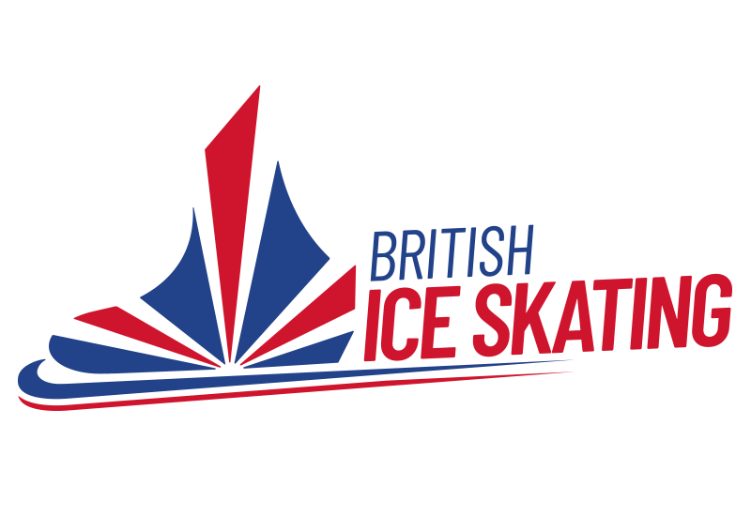

Coach Application Form

This form MUST be submitted through the British Ice Skating Membership Portal

This form may be used for all levels of application

Last updated: 18/04/2023

Trainee Coach Details
Name:
BIS Number:
Email:
Current Rink:
Discipline/s:
Current Level Coach:
Level Applying For:
Signature:
Date:
Please note this document MUST be signed and not typed.
Please include copies of any Sports Coach UK courses you may have attended within the last 3 years.
Please include a copy of a current First Aid and Safeguarding Certificate (if applicable)

Mentor Coach Details
The chosen mentor has to have held a level 2 coaching licence for at least 5 years and attended the mentoring sessions at the coaches conference.

Name:

BIS Number:

Email:

Signature of Mentor:

Date:
Please note this document MUST be signed by the Mentor and not typed.
Please note mentor hours can only be taken once an application has been submitted and confirmed. Hours completed before an application has been confirmed will not be accepted.

Coach Self-Declaration Form
Full Name:
Have you ever been known to any children’s Services department or Police as being a risk or potential risk to children? | YES / NO  (if yes, provide information)
Have you ever been the subject of any disciplinary investigation and/or sanction by any organisation due to concerns about your behaviour towards children? | YES / NO  (if yes, provide information)

Confirmation of Declaration (tick box)
I agree that the information provided here may be processed in connection with licensing purposes and I understand that a license may be withdrawn or disciplinary action may be taken if information is not disclosed by me and subsequently come to the BIS’s attention
In accordance with the organisation’s procedures if required, I agree to provide valid DBS certificate and consent to the organisation clarifying any information provided on the disclosure with the agencies providing it
I agree to inform the organisation within 24 hours if I am subsequently investigated by any agency or organisation in relation to concerns about my behaviour towards children or young people.
I understand that the information contained on this form, the results of the DBS check and information supplied by third parties may be supplied by BIS to other persons or organisations in circumstances where this is considered necessary to safeguard children.
I, (name) …………………….. confirm receipt of the BIS Codes of Conducts and agree to abide by the terms and conditions therein. I, (name) ……………………... confirm the information on this form to be true and complete. I, (name) …………………….. confirm I have included copies of relevant in date safeguarding course certificates. I, (name) ……………………... confirm and understand that, if eligible, that prior to undertaking the license BIS may also request the completion of a Disclosure and Baring Check. The results of which may be shared with partner agencies.
Print Name
Signature
Date of Signature

References
Please provide the details of two people who can provide us with a reference. Ideally one of them should have experience of you working with children and vulnerable adults. If you have not had work experience, we are happy to also accept an academic reference.
Referees must have known you for at least 2 years.
Name:  Organisation:  Email Address: | Name:  Organisation:  Email Address:
How long have you known this person and in what capacity: | How long have you known this person and in what capacity:

The information I enclose with this application is correct and any changes in my circumstances I will inform the BIS head office

Signature of Skater

Date

